DSA LAB ASSIGNMENT 2

Q1.Create a view by name book which contains bookname,author name and price and display the same.

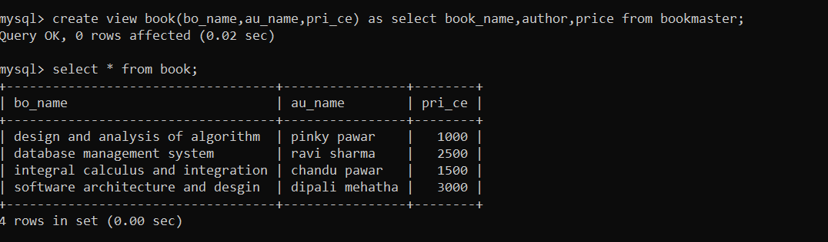

Q2.Create a view by name Unreturned books which contain book_id,bookname and display the same.

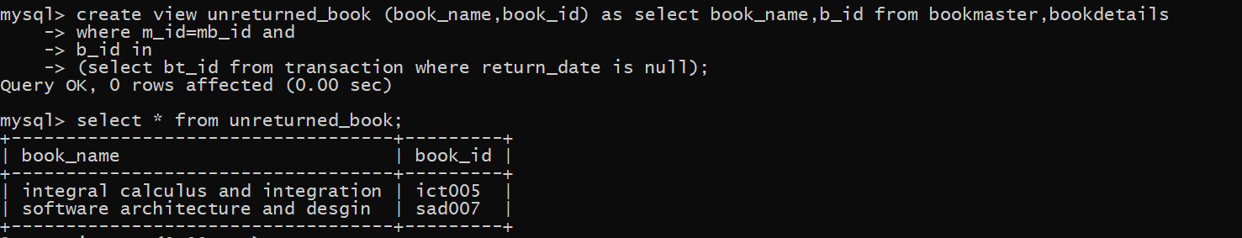

Q3.create a view student view having all fields of student and adda record through student view.

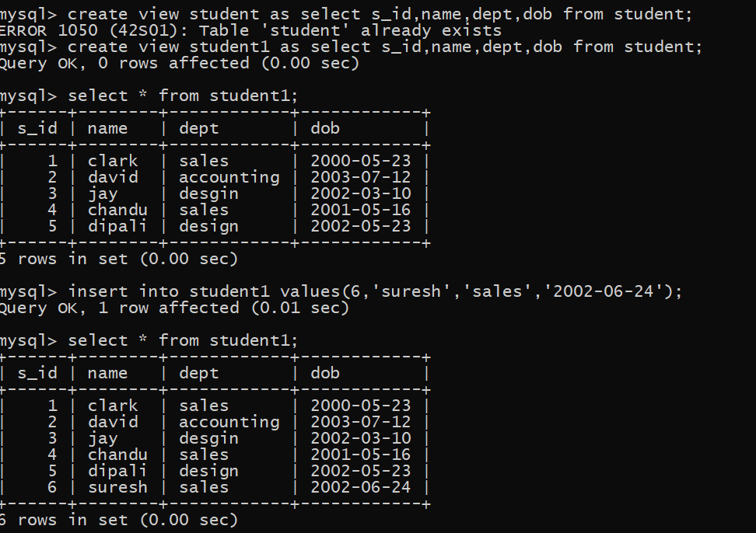

Q4.show bookname of the books which are borrowed by more than one person .use join

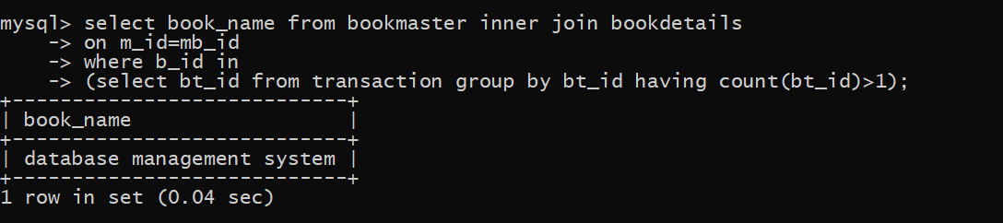

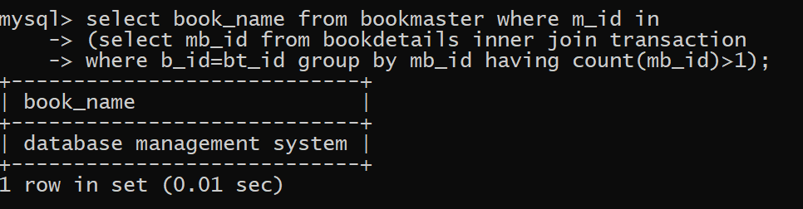

Q5.Display all the books master ids along with the issued date and student id to which book was issued use join.

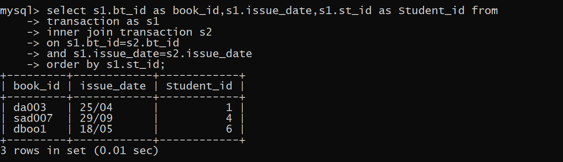

Q6.display book_name and student name who has borrowed that book.

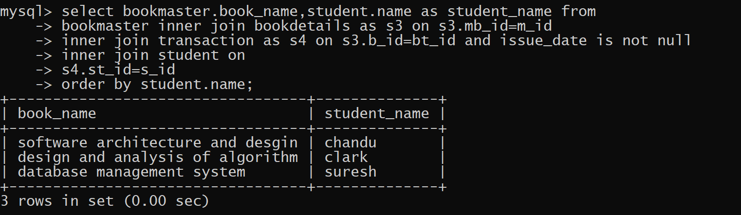

Q7.add a record of a student with repeated roll.no .what is your observation.

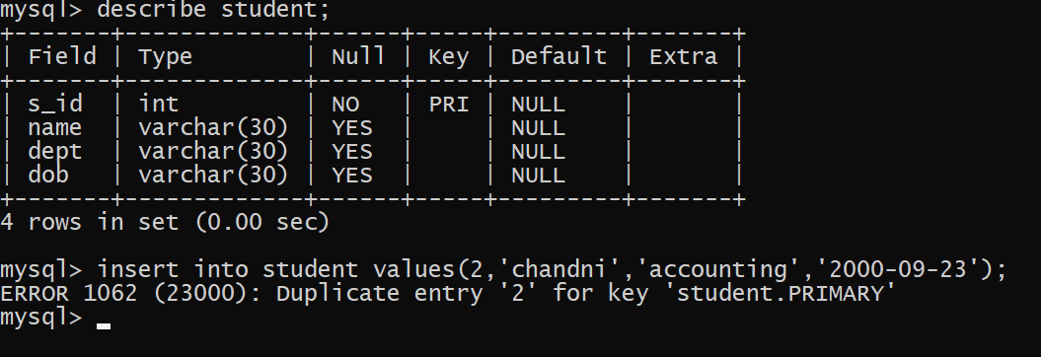

Q.8 demonstrate use of tcl commands by performing following actions

Q9.Create a save point s1

Delete one of the record from transaction

Undo the previous change

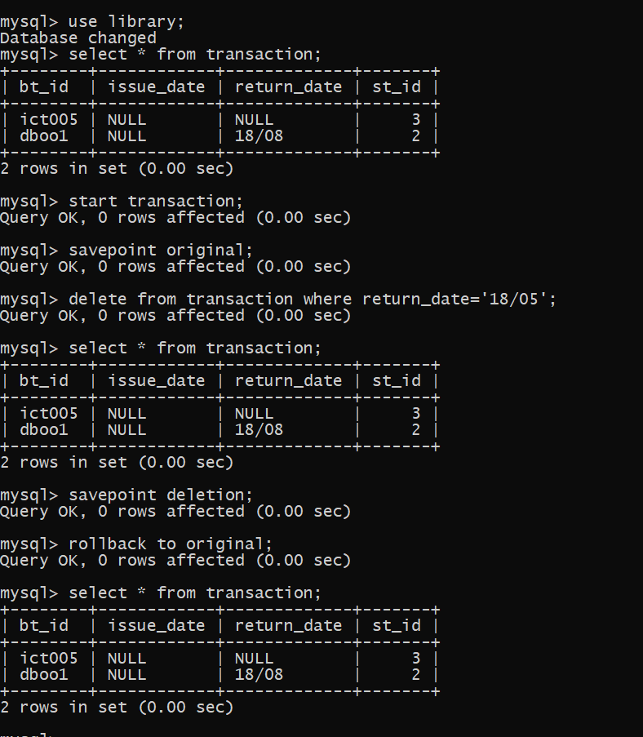

Q9.create a savepoint s2

Add a record in student table .

Use commit

Undo the previous change uptil s2.

What is your observation.

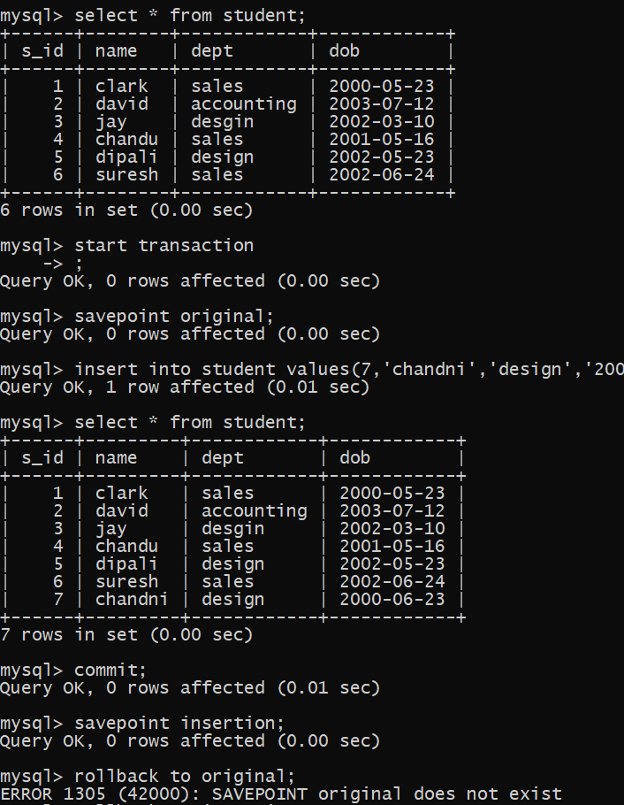

Q.11 Remove a record from student table of a particular student identified by student_id.

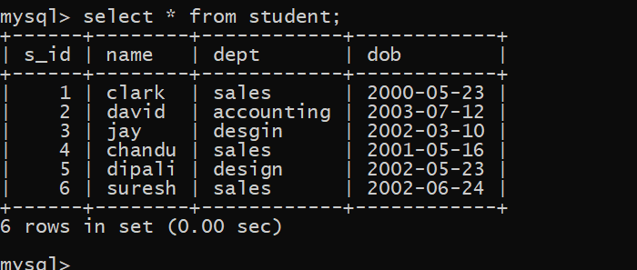

Q12.show the book_name of the books which are borrowed so far.use join

